String v/s String Builder v/s String Buffer

**String:**

1. String is not datatype, it’s a Class.
2. String variable’s are stored into string pool.
3. Once string reference is changed the old value that exist value in the string pool does not change it remains into the String Pool.

Example:

String name = “Book”;

*This book value will stay remains into the string pool even we create new value.*

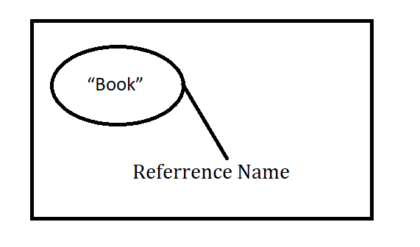

*When we insert new value into string pool the old value will stay remains into string pool.*

Example: String name = “Pen”;

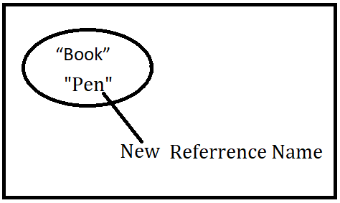

After we add new string value then this new value added after that also old value will remains their into the string pool.

**String Buffer:**

1. Here string values are stored into the Stack.
2. But here if we change the value then the New value will replace old value.
3. String Builder is Synchronized and thread Safe.
4. Performance of the String Buffer is Slower.

First we add value “Book”.

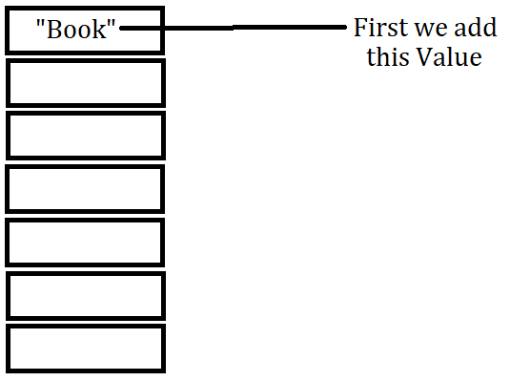

If we change the Book Value to Pen then the Book reference from Stack will replaced with new value like what we add like Pen.

String name = “Pen”;

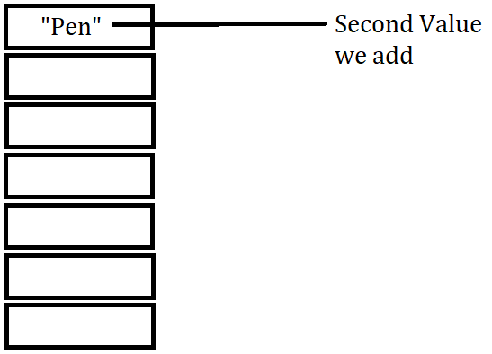

**String Builder:**

1. This one is same as String Buffer.
2. But string Builder is not thread safe
3. String Builder is not Synchronized
4. For this reason String Builder is faster.